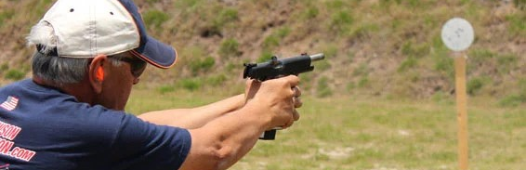  6th Annual  Great Plains Speed Shooting Championship  Kiowa Gun Club, Great Bend, KS  June 14, 2025 8:00 AM  This is a 150 round steel target event. Course of fire will be Steel Challenge and Outlaw Steel Challenge Stages.  Awards will be given in each of 8 Gun Divisions. Awards will be given in 5 Competition Categories in both Rimfire and Centerfire. Overall Awards will be based on a shooter’s score in relation to Par which gives all competitors an equal opportunity.  Steel Master will be awarded to best all-around shooter.  For entry form, rules and discount for early registration see kiowagunclub.wixsite.com/kiowagunclub | ────  Shoot is limited to the first 50 entries.  ────  Proceeds from this shoot support youth shooting activities in Central Kansas.  ────  Brass will only be collected at end of event.  ────  ────

